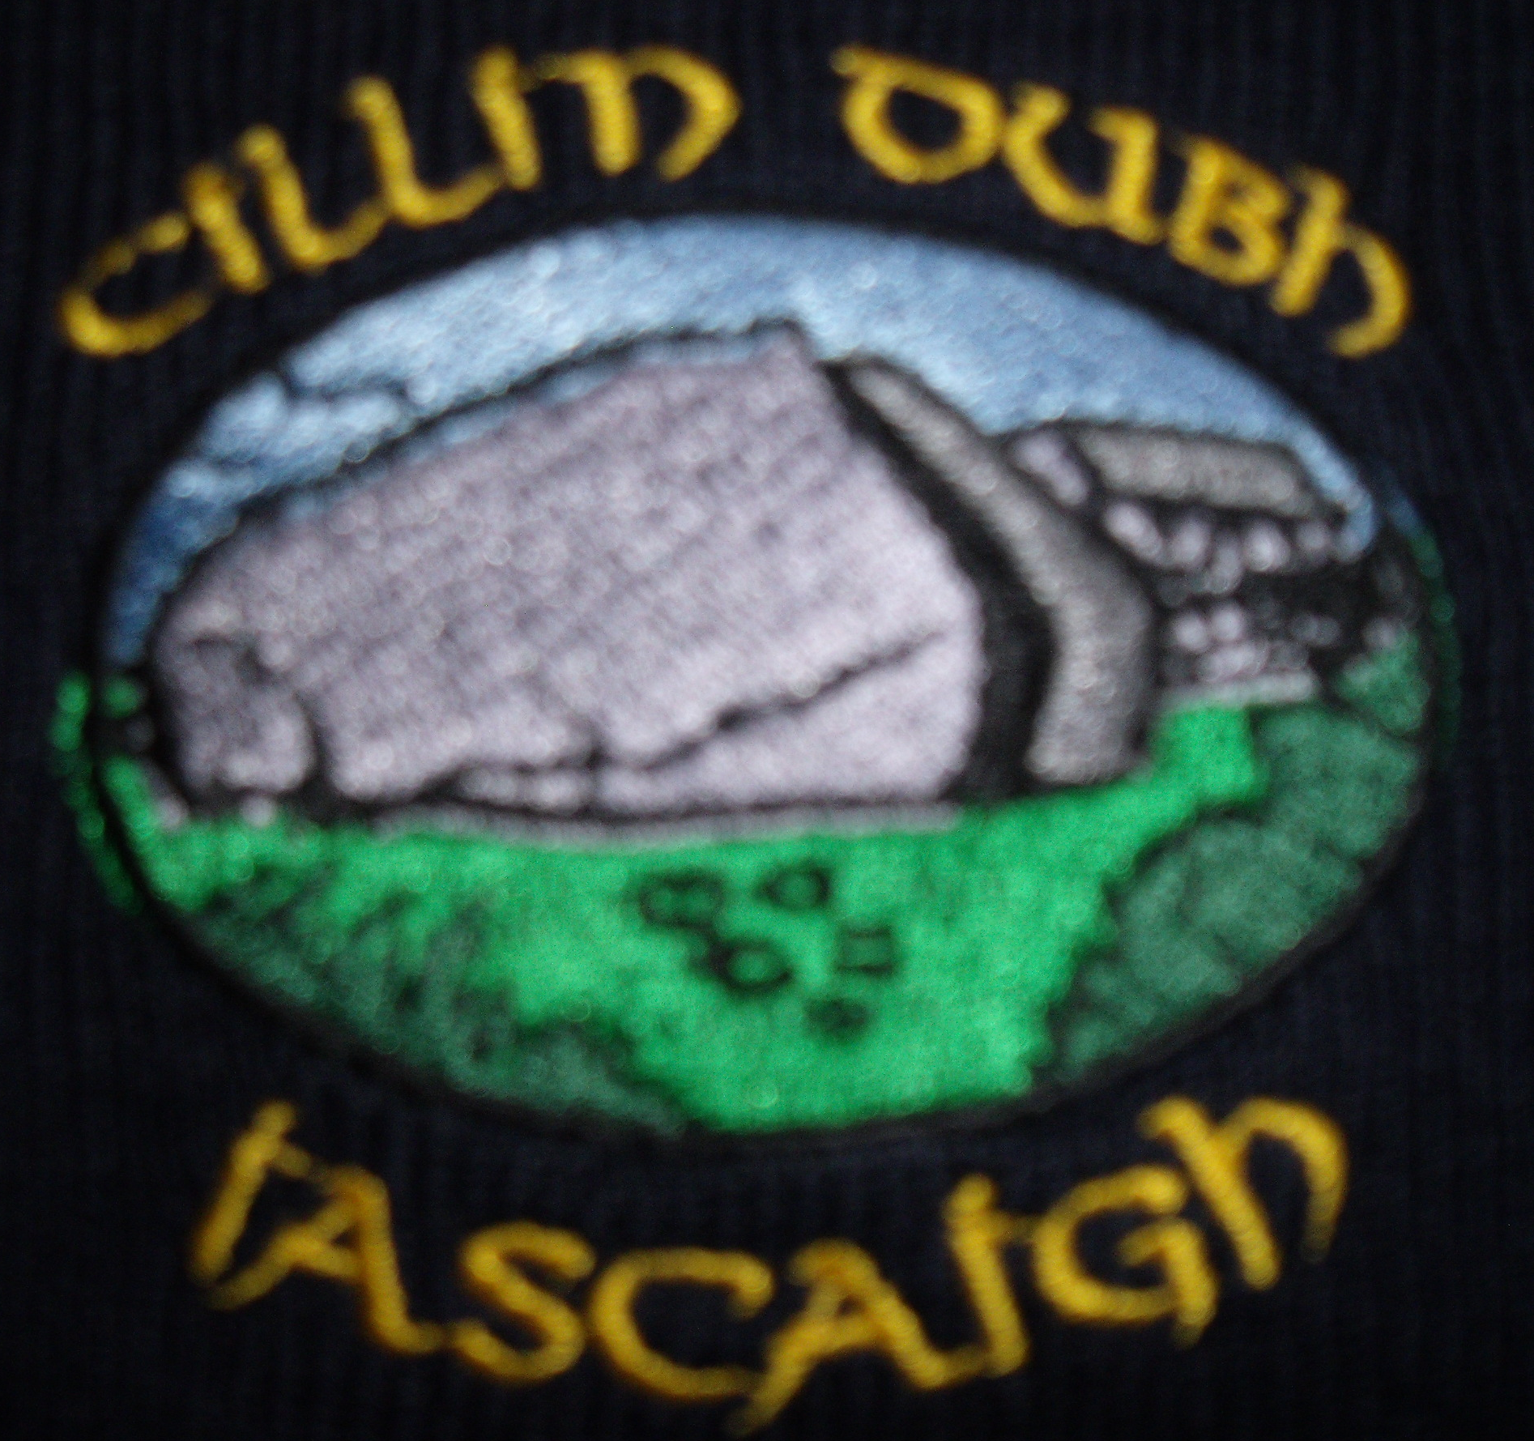
Killeenduff NS
2022 - 2023 School Calendar
  August ‘22
  Su | M | Tu | W | Th | F | S
   | 1 | 2 | 3 | 4 | 5 | 6
  7 | 8 | 9 | 10 | 11 | 12 | 13
  14 | 15 | 16 | 17 | 18 | 19 | 20
  21 | 22 | 23 | 24 | 25 | 26 | 27
  28 | 29 | 30 | 31
  September ‘22
  Su | M | Tu | W | Th | F | S
   |  |  |  | 1 | 2 | 3
  4 | 5 | 6 | 7 | 8 | 9 | 10
  11 | 12 | 13 | 14 | 15 | 16 | 17
  18 | 19 | 20 | 21 | 22 | 23 | 24
  25 | 26 | 27 | 28 | 29 | 30
  October ‘22
  Su | M | Tu | W | Th | F | S
   |  |  |  |  |  | 1
  2 | 3 | 4 | 5 | 6 | 7 | 8
  9 | 10 | 11 | 12 | 13 | 14 | 15
  16 | 17 | 18 | 19 | 20 | 21 | 22
  23 | 24 | 25 | 26 | 27 | 28 | 29
  30 | 31
  November ‘22
  Su | M | Tu | W | Th | F | S
   |  | 1 | 2 | 3 | 4 | 5
  6 | 7 | 8 | 9 | 10 | 11 | 12
  13 | 14 | 15 | 16 | 17 | 18 | 19
  20 | 21 | 22 | 23 | 24 | 25 | 26
  27 | 28 | 29 | 30
  December ‘22
  Su | M | Tu | W | Th | F | S
   |  |  |  | 1 | 2 | 3
  4 | 5 | 6 | 7 | 8 | 9 | 10
  11 | 12 | 13 | 14 | 15 | 16 | 17
  18 | 19 | 20 | 21 | 22 | 23 | 24
  25 | 26 | 27 | 28 | 29 | 30 | 31
  January ‘23
  Su | M | Tu | W | Th | F | S
  1 | 2 | 3 | 4 | 5 | 6 | 7
  8 | 9 | 10 | 11 | 12 | 13 | 14
  15 | 16 | 17 | 18 | 19 | 20 | 21
  22 | 23 | 24 | 25 | 26 | 27 | 28
  29 | 30 | 31
  February ‘23
  Su | M | Tu | W | Th | F | S
   |  |  | 1 | 2 | 3 | 4
  5 | 6 | 7 | 8 | 9 | 10 | 11
  12 | 13 | 14 | 15 | 16 | 17 | 18
  19 | 20 | 21 | 22 | 23 | 24 | 25
  26 | 27 | 28
  March ‘23
  Su | M | Tu | W | Th | F | S
   |  |  | 1 | 2 | 3 | 4
  5 | 6 | 7 | 8 | 9 | 10 | 11
  12 | 13 | 14 | 15 | 16 | 17 | 18
  19 | 20 | 21 | 22 | 23 | 24 | 25
  26 | 27 | 28 | 29 | 30 | 31
  April ‘23
  Su | M | Tu | W | Th | F | S
   |  |  |  |  |  | 1
  2 | 3 | 4 | 5 | 6 | 7 | 8
  9 | 10 | 11 | 12 | 13 | 14 | 15
  16 | 17 | 18 | 19 | 20 | 21 | 22
  23 | 24 | 25 | 26 | 27 | 28 | 29
  30
  May ‘23
  Su | M | Tu | W | Th | F | S
   | 1 | 2 | 3 | 4 | 5 | 6
  7 | 8 | 9 | 10 | 11 | 12 | 13
  14 | 15 | 16 | 17 | 18 | 19 | 20
  21 | 22 | 23 | 24 | 25 | 26 | 27
  28 | 29 | 30 | 31
  June ‘23
  Su | M | Tu | W | Th | F | S
   |  |  |  | 1 | 2 | 3
  4 | 5 | 6 | 7 | 8 | 9 | 10
  11 | 12 | 13 | 14 | 15 | 16 | 17
  18 | 19 | 20 | 21 | 22 | 23 | 24
  25

School Closed/Holidays
First and Last day of school

